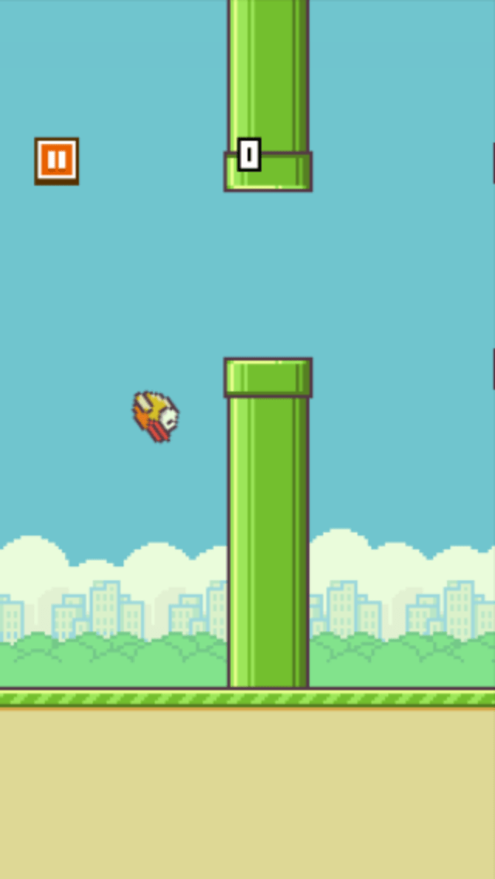**Flappy Bird on TM4C123**

My project would be to create a clone of the then popular Flappy Bird mobile game in which a player controls a bird, attempting to fly between columns of green pipes without hitting them. The game would be rendered on the TFT display, featuring high quality transparent sprites. The bird would be controlled by a tactile button press.

The project would implement the following threads, semaphores, schedulers, and buffers, inter-process communication:

* **Threads**
  + Update_Bird (update bird position and check for collision)
  + Update_Pipes (spawn and update ceiling and ground pipe arrays)
  + Check_ButtonPress (check for button press)
  + Update_Score
* A close up of a device

  Description automatically generated**Semaphores**
  + Button_Debounce
  + Interface_TFT
* **Buffers**
  + Button_FIFO
  + Score_FIFO

The project would also implement the following data structures:

* **Data Structures**
  + Bird struct (tracks birdPosY and birdSpeed)
  + Pipe struct (tracks X and Y position)
  + Arrays for ceiling pipes and ground pipes

Testing transparent sprite rendering

with scaling